Inverter

ECE 09414 - 2 VLSI

Dr. Hanafi

Everett Jones

9/26/17

I. Introduction

The goal of this procedure was to utilize Cadence in order to create two inverters and produce graphs of their inputs and outputs. These graphs are created in order to see how the input and output of an inverter circuit are related.

II. Procedure

Using Cadence the first inverter circuit was created and can be seen in Figure 1.1. This circuit has a varying input and a constant voltage source, VDD. The output is controlled by the varying input signal that switches the output between zero and five volts. This switch is done by varying the input state with a signal period of 2n whereas the simulation is stopped at 4n. The graph created by this simulation can be seen in Figure 1.2 which shows how the output signal changes as the input signal changes.

The second inverter circuit was created with a voltage source in place of the input pin which can be seen in Figure 2.1. This voltage source was used to vary the voltage entering the circuit as to show how the state of the inverter is changed. The voltage source changes over time from zero to five volts in steps of 0.2 volts. The graph produced shows how the output changes rather than the constant switching of the inverter state. The graph can be seen in Figure 2.2.

III. Results

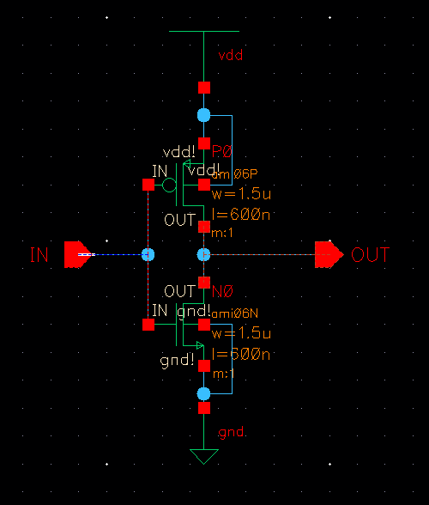

Figure 1.1: Schematic of inverter circuit with a pulsing input signal.

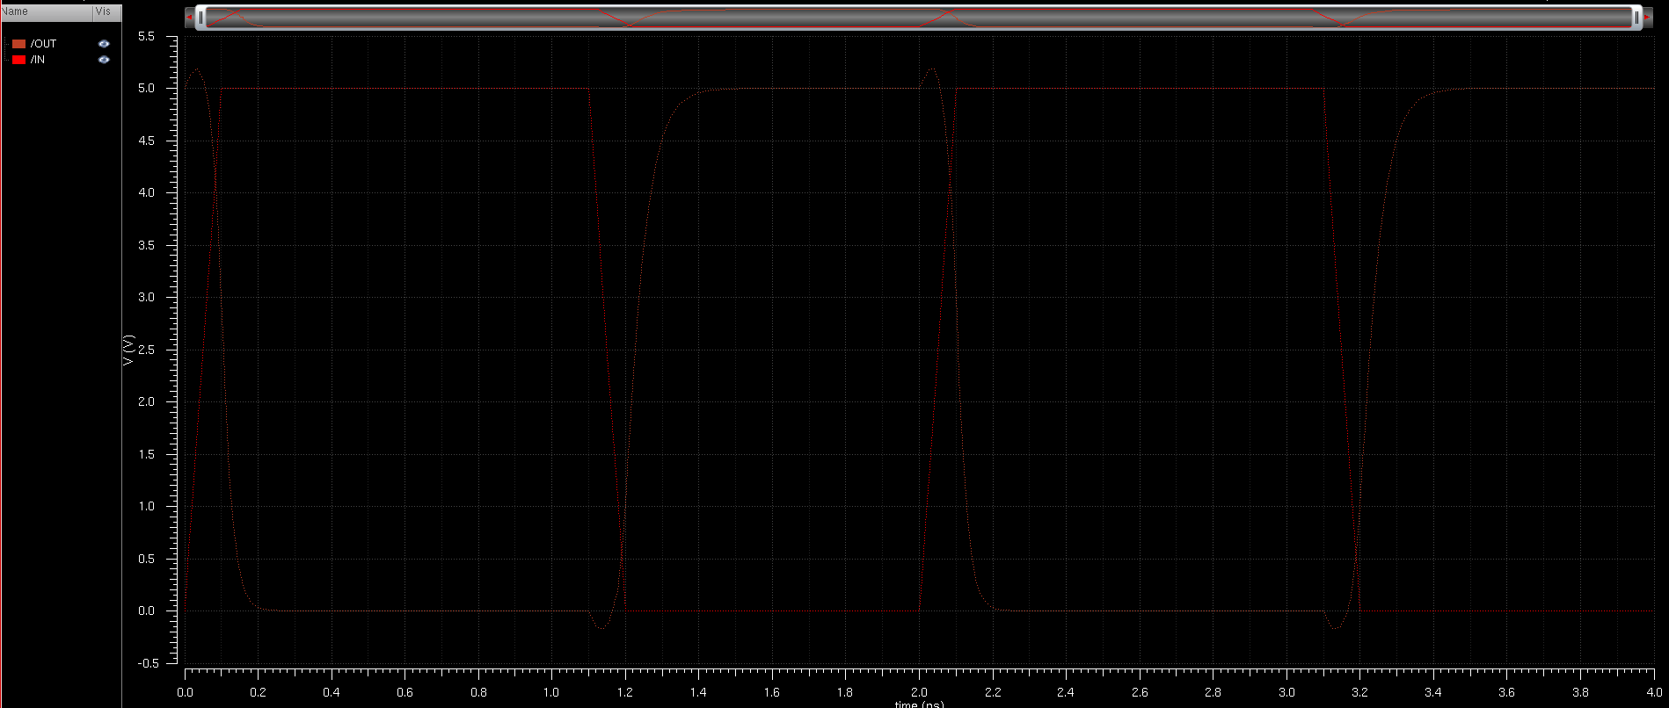

Figure 1.2: Input voltage compared to output voltage of the first inverter..

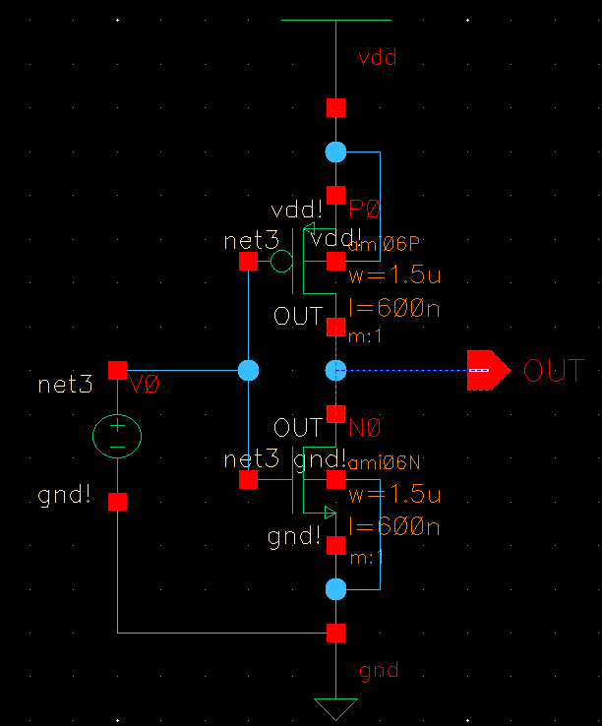

Figure 2.1: Schematic of the inverter circuit with a varying input voltage..

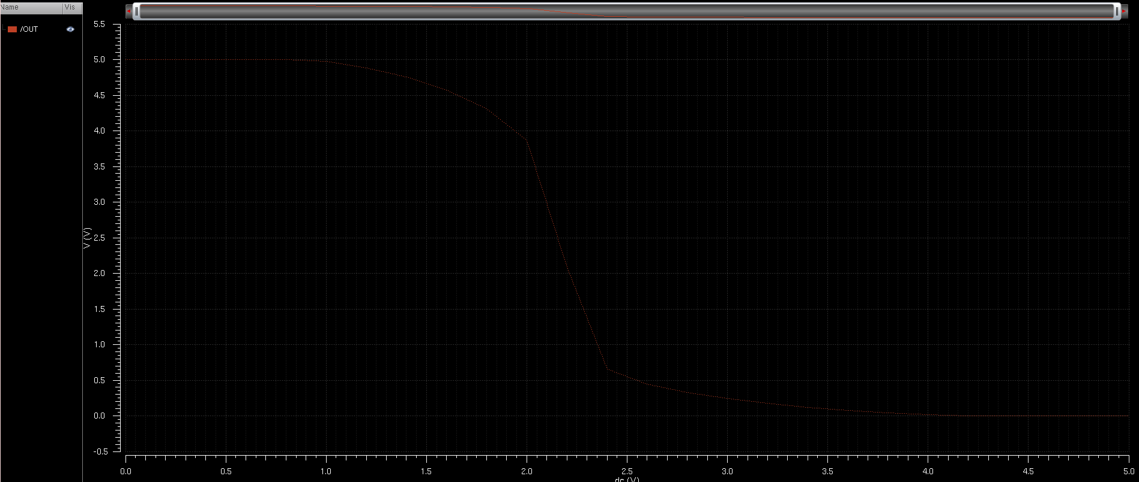

Figure 2.2: Output signal of the inverter with a varying input voltage.

IV. Conclusions

From this lab procedure it can be seen that as the input changes from zero volts to five volts the output signal changes from a five volt output to a zero volt output. This change can be seen to be gradual, but very quick as it takes only 0.2ns to change in state. This can be seen further as the varying voltage input graph is analyzed. As the input voltage starts to increase the output voltage begins to decrease, but as the input reaches two volts the output voltage can be seen to drop rapidly.